Performance Report (Power BI Project)

1. Power Query

Importing dataset

Transform & Cleaning the data

Rename the table’s name according to data

Removing the duplicates from tables

Changing the data type of Date column into Date

1. Virtual tables

Dim_Date:

Dim_Date = CALENDAR(DATE(2022, 01, 01),DATE(2024, 12, 31))

Adding a column Inpast in Dim_Date table:

Inpast =

VAR lastsalesdate = MAX(Fact_Sales[Date_Time])

VAR lastsalesdatePY = EDATE(lastsalesdate, -12)

RETURN

Dim_Date[Date]<=lastsalesdatePY

Slicer: 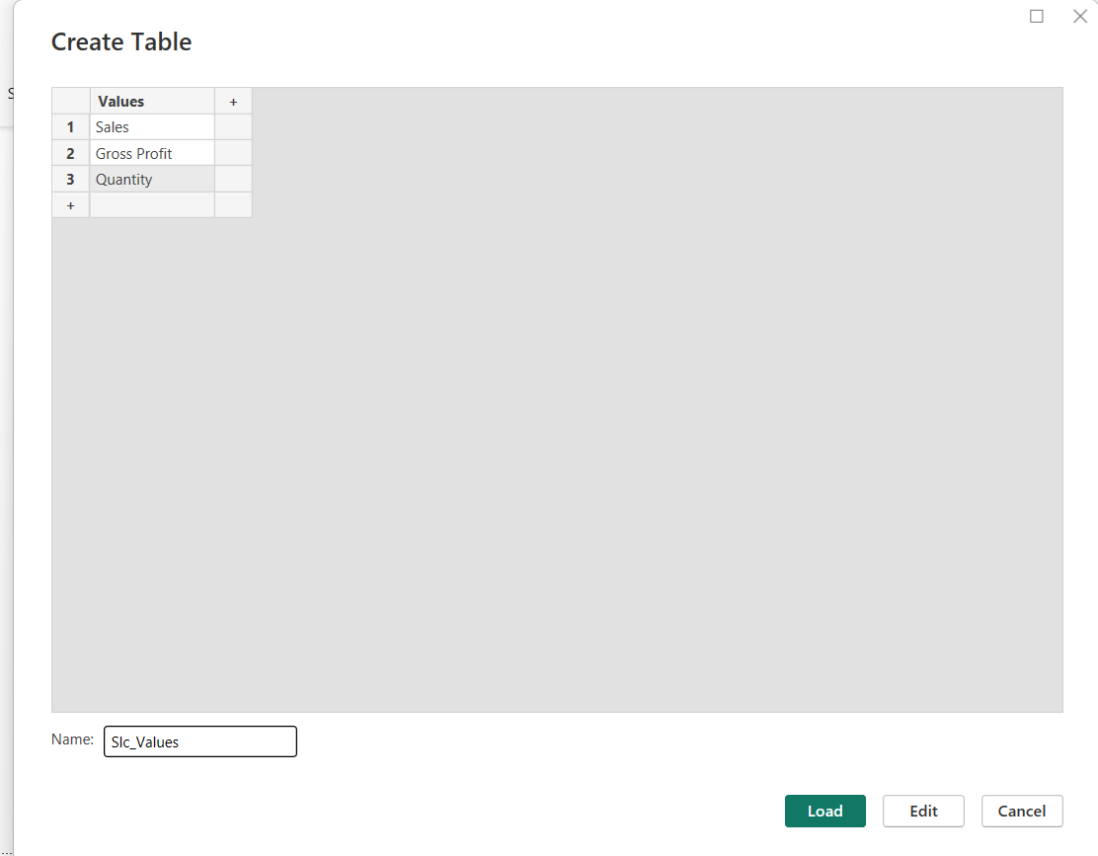

1. The Model: Building Measures and Core Visuals:
2. Base Measures
3. Cost of Goods (COGs)

COGs = SUM(Fact_Sales[COGS_USD])

1. Sales

Sales = SUM(Fact_Sales[Sales_USD])

1. Quantity

Quantity = SUM(Fact_Sales[quantity])

1. Gross Profit

Gross Profit = [Sales] - [COGs]

1. PYTD (Prior Year to Date)
2. PYTD_Sales = CALCULATE([Sales], SAMEPERIODLASTYEAR(Dim_Date[Date]), Dim_Date[Inpast]=TRUE )
3. PYTD_Quantity = CALCULATE([Quantity], SAMEPERIODLASTYEAR(Dim_Date[Date]), Dim_Date[Inpast]=TRUE )
4. PYTD_GrossProfit = CALCULATE([Gross Profit], SAMEPERIODLASTYEAR(Dim_Date[Date]), Dim_Date[Inpast]=TRUE )
5. YTD (Year to Date)
6. YTD_Sales = TOTALYTD([Sales],Fact_Sales[Date_Time])
7. YTD_Quantity = TOTALYTD([Quantity],Fact_Sales[Date_Time])
8. YTD_GrossProfit = TOTALYTD([Gross Profit],Fact_Sales[Date_Time])
9. SWITCH
10. S_PYTD =

VAR selected_value = SELECTEDVALUE(Slc_Values[Values])

VAR result = SWITCH(selected_value,

    "Sales", [PYTD_Sales],

    "Quantity", [PYTD_Quantity],

    "Gross Profit", [PYTD_GrossProfit],

    BLANK()

)

RETURN

result

1. S_YTD =

VAR selected_value = SELECTEDVALUE(Slc_Values[Values])

VAR result = SWITCH(selected_value,

    "Sales", [YTD_Sales],

    "Quantity", [YTD_Quantity],

    "Gross Profit", [YTD_GrossProfit],

    BLANK()

)

RETURN

Result

1. YTD vs PYTD = [S_YTD] - [S_PYTD]
2. Formatting and Conditional Formatting

Using rules to define the colors to header card for different aspect(values, labels & background)

1. Treemap, Waterfall Chart, Line and Stacked Column Chart, Scatter Chart with Zoom Slider
2. Dynamic Chart Titles, Axis Titles, Formatting

Created measures to use dynamic chart titles:

1. For Waterfall Chart:

_Waterfall title = SELECTEDVALUE(Slc_Values[Values]) & " YTD vs PYTD | Month - Country - Product "

1. For Line and Stacked Column Chart:

_Column Chart title = SELECTEDVALUE(Slc_Values[Values]) & " YTD & PYTD | Month"

1. For Scatter Chart:

_Scatter title = " Account Profitability Segmentation | GP% and " & SELECTEDVALUE(Slc_Values[Values])

1. Dynamic Report Title

_Report title = " Plant Co. " & SELECTEDVALUE(Slc_Values[Values]) & " Performance " & SELECTEDVALUE(Dim_Date[Date].[Year])